An Edge-Assisted Architecture for Context- Aware Matching in Real-Time Goods Transportation Systems

N. R. Sathis Kumar | B. Rohith | B. Yaswanth Babu
Department of computer Science and  Engineering | Department of computer Science and  Engineering | Department of computer Science and  Engineering
Kalasalingam Academy of Research and  Education | Kalasalingam Academy of Research and  Education | Kalasalingam Academy of Research and  Education
Krishnankovil, India | Krishnankovil, India | Krishnankovil, India
sathiskumar@klu.ac.in | 99220041454@klu.ac.in | 99220041445@klu.ac.in

A. Sai Prajwin | Y. Vinayasree
Department of computer Science and Engineering | Department of computer Science and Engineering
Kalasalingam Academy of Research and  Education | Kalasalingam Academy of Research and  Education
Krishnankovil, India | Krishnankovil, India
99220041438@klu.ac.in | 99220041423@klu.ac.in

Abstract—Because of centralized architectures, slow response times, and reliance on middlemen, the logistics industry consistently struggles to effectively match the demands for the transportation of goods with the availability of vehicles. An edge-assisted architecture for context-aware, real-time matching in decentralized goods transportation systems is proposed in this paper. The system distributes computational loads among localized edge nodes, reduces latency, and supports offline-resilient operations by utilizing a hybrid edge–cloud infrastructure. In order to optimize vehicle allocation, a novel context-aware matching algorithm is presented that integrates driver trust scores, historical reliability, load compatibility, geospatial proximity, and real-time traffic conditions. By placing edge micro-controllers at key network locations, localized decision-making is made possible and the need for constant cloud connectivity is decreased. Comparing experimental evaluations to traditional centralized models reveals significant gains in booking efficiency, decreased vehicle idle time, and quicker response rates. Through transparent, technologically driven service accessibility, this architecture not only improves system responsiveness and scalability but also gives independent transport operators more power. The suggested solution is a first step toward distributed logistics platforms that are intelligent and flexible enough to operate in resource-constrained and urban settings.
Keywords—Real-Time Transportation Systems, Edge Computing, Context-Aware Matching, Hybrid Edge–Cloud Architecture, Decentralized Booking Platforms, Vehicle Allocation Optimization, Sustainable Development Goal 8 (Decent Work and Economic Growth), Sustainable Development Goal 11 (Sustainable Cities and Communities)

Introduction
Logistics and transportation networks are under unprecedented pressure to become faster, more adaptive, and more intelligent due to the exponential growth of e-commerce, urbanization, and consumer expectations [1], [2]. Due to intrinsic constraints like high latency, inadequate scalability,
and a lack of contextual intelligence, traditional centralized fleet management systems frequently fail to meet these demands [3], [4]. These drawbacks are especially noticeable in underserved and geographically diverse areas, where reliance on cloud-based operations frequently causes disruptions and network infrastructure may be unreliable [5].
A new era of intelligent logistics has been made possible by the development of edge computing, the Internet of Things (IoT), and artificial intelligence (AI). Bringing computation closer to the data source, edge computing in particular enables real-time processing, reduced latency, and offline-resilient system behavior—features essential to sustaining uninterrupted service in logistics environments. The integration allows for highly optimized, dynamic, and scalable transport services when paired with context-aware systems that can evaluate factors such as driver history, load compatibility, vehicle availability, and route congestion.
In light of contemporary smart cities and rural areas that are being digitally transformed, the necessity for a decentralized and intelligent framework becomes even more apparent. Real-time responsiveness is crucial in these situations for sustainability, safety, and efficiency. However, cloud-dependent platforms frequently experience service degradation under high load or limited connectivity, and they frequently introduce latency due to distance from the data source. By facilitating quicker, more pertinent decision- making and lowering the communication overhead between nodes and central servers, edge computing—enhanced with federated intelligence and localized data processing— addresses these issues.
Intelligent Transportation Systems (ITS) have advanced, but current implementations are still mostly cloud-centric and do not have the adaptive capabilities needed for fine-grained, real-time edge decision-making. Furthermore, a lot of current systems use rule-based or static allocation strategies that don't take dynamically changing logistical conditions into

consideration. The efficiency of otherwise intelligent infrastructure is undermined by this restriction, which frequently leads to inefficiencies like longer idle vehicle times, postponed pickups, and underutilized capacity.
This paper suggests a novel edge-assisted architecture created especially for context-aware, real-time goods transport matching in order to address these issues. By using a hybrid edge–cloud architecture, the suggested system distributes computation to nearby edge nodes while keeping centralized control over analytics and historical modeling. The system's innovative context-aware matching algorithm, which combines load parameters, traffic flow data, trust metrics, and geospatial proximity, optimizes vehicle-service matching dynamically. Additionally, the system facilitates offline operation and resilience in areas with low connectivity, which is a crucial feature for the deployment of logistics services in an equitable manner.
This study advances edge-enabled intelligent transport design, enhances the effectiveness and inclusivity of logistics services, and addresses Sustainable Development Goals (SDGs) like SDG 10 (Reduced Inequalities), SDG 11 (Sustainable Cities and Communities), and SDG 9 (Industry, Innovation, and Infrastructure). This work supports the larger goals of equitable technology access and sustainable digital transformation by putting forth a modular, scalable, and context-sensitive system.

RELATED WORK
The complexity of real-time transportation systems, edge computing in logistics, and context-aware service allocation have all been the subject of extensive research in recent years. One of the main topics of logistics 4.0 has been the transition of Fleet Management Systems (FMS) from static, centralized architectures to more dynamic, data-driven models [1]. By enabling near real-time monitoring and decision-making across thousands of connected devices, Dintén et al.'s real- time distributed and scalable architecture revolutionized fleet operations [1]. Their results highlight the increasing demand for intelligent control systems and decentralization in contemporary logistics.
When Kotsialos and Vassilakopoulou investigated the relationship between enterprise fleet management and traffic control systems, they found that dynamic traffic interventions like ramp metering and route guidance did not work well with real-time fleet coordination [2]. According to their research, logistics systems that only use enterprise control and ignore contextual traffic data are operationally inefficient. Our suggested architecture fills this gap by utilizing edge-based optimization and context-aware matching.
The intricacy of dynamic logistics planning was further highlighted by Fang et al., who provided a framework for decision-making regarding order allocation in robust supply chains that incorporates a number of factors, including digital capability and dependability [13]. Our architecture attempts to address the issue of such models' inability to react to real-time changes in operational environments, despite their effectiveness in strategic decision-making.
Platforms based on IoT and AI have also attracted a lot of interest since they make it possible for intelligent control and real-time monitoring in transportation networks. In order to improve traffic efficiency and dynamically manage congestion, Dui et al. presented an Internet of Things-enabled
model for intelligent transportation systems that makes use of V2X-enabled vehicles [3]. Similarly, Yin et al. focused on operational visibility and environmental sustainability by combining AI and IoT technologies to propose a model that predicts CO2 emissions during logistics transport [4]. Our method expands on these concepts by integrating trust and environmental metrics into real-time matching choices to attain sustainability and efficiency.
Promising outcomes for the development of smart cities have been observed in the implementation of intelligent transportation systems (ITS) in urban environments. Elassy et al. examined a number of ITS elements, including mobility prediction models, virtual traffic lights, and vehicular ad-hoc networks, showing how real-time communication infrastructure enhances sustainability, efficiency, and safety [5]. But as Hazarika et al. point out, these models frequently don't integrate with edge computing, which restricts their scalability and responsiveness under high-load scenarios [6]. In order to overcome this constraint, our work distributes decision-making in real-time and lowers latency by deploying computational resources at the edge.
In intelligent transportation, federated learning (FL) has become a supplementary method to edge computing. By avoiding the latency of cloud dependence and training decentralized models directly at the edge nodes, Zhang et al. and Zhou et al. showed how FL can improve data privacy and system responsiveness [7], [8]. To improve learning efficiency in vehicular networks, Zhou et al. specifically proposed an Adaptive Segmentation enhanced Asynchronous Federated Learning (AS-AFL) model. Although promising, the majority of FL-based architectures today concentrate on vehicle clustering or traffic prediction. Our system differs in that it uses contextual intelligence to allocate services in a distributed and federated computing environment.
Belkacem demonstrated a strong hybrid edge-cloud-fog architecture designed to maximize big data processing in Internet of Things applications for smart cities [9]. This was furthered by Afzal et al., who suggested a latency-aware, fault-tolerant resource scheduling framework for fog-based transportation systems, highlighting the function of orchestration and microservices in real-time performance management [10]. These findings support the core of our system architecture, which similarly maintains service consistency under changing network and resource conditions while balancing computational loads across edge and cloud layers.
While Nagappan et al. presented hybrid deep learning models for energy-efficient intelligent transport operations [12], Manchanda et al. suggested an adaptive caching framework to improve context delivery for IoT systems [11] in the context of context-aware service management. A key idea in our real-time matching algorithm, these systems support the feasibility of context-aware logic in transportation. Additionally, Maamar et al. addressed the problem of data freshness and security trade-offs in distributed computing by introducing guidelines for combining edge services with cloud-based resources [16].
Because blockchain-based decentralized systems can provide secure communication, immutability, and trust, they are becoming more and more popular in the logistics industry. Blockchain was investigated by Li et al. to improve transparency in decentralized logistics, including goods

tracking and identity verification in their Decentralized Logistic Management System (DLMS) [14]. The dynamic responsiveness made possible by edge-based real-time decision-making is absent from DLMS, despite its emphasis on security and transparency. Our framework blends the intelligence of edge-based optimization with the trust components of decentralization.
Using centralized model coordination and embedded edge devices, Salave presented a cloud-edge hybrid deep learning architecture for real-time traffic management [15]. Their strategy demonstrated appreciable improvements in resource efficiency and responsiveness. In a similar vein, Shaikat introduced a low-code Industrial IoT platform that improved rural digital infrastructure by bringing edge processing to underprivileged areas [17]. These studies highlight how important localized intelligence is to building inclusive digital ecosystems, which is a goal that this work supports.
In their review of cooperative digital logistics systems in rural settings, Moazzeni and Sgarbossa provided a taxonomy for the use of digital technology in both urban-to-rural and rural-to-urban models [18]. Using real-world datasets, Kaleem et al. proposed an energy-efficient federated learning system for intelligent transportation, showing promising outcomes in predictive performance and communication efficiency [20]. All of these studies support the requirement for intelligent, decentralized platforms that can adjust to different infrastructure capacities.

METHODOLOGY
The creation of the suggested edge-assisted, context-aware architecture makes use of a wide range of contemporary platforms and technologies that have been carefully chosen to maximize real-time performance, scalability, and adaptability under varied network and environmental circumstances. The key technologies and ideas incorporated into the system design are described in detail in the ensuing subsections.

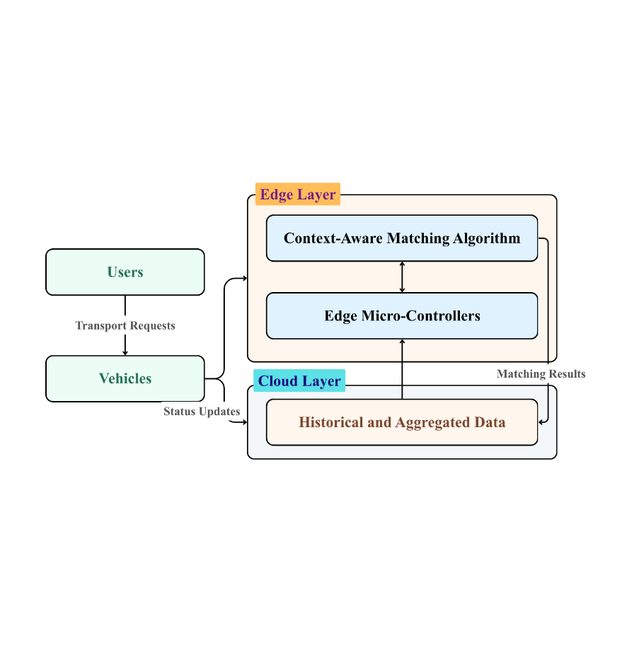
Fig. 1. System Architecture

The suggested edge-assisted system architecture for real- time goods transportation is shown in Fig. 1. It shows how distributed edge nodes, cloud backends, IoT-enabled cars, and context-aware decision algorithms can all be integrated. To guarantee scalable, low-latency, and intelligent transport management, the architecture places a strong emphasis on offline resilience, federated learning, localized processing, and real-time data collection.
Component / Technology | Layer in Architecture | Purpose / Role
Kubernetes / K3s | Edge Computing Layer | Orchestration of edge nodes and load balancing
Docker | Edge Computing Layer | Containerization for lightweight deployments
AWS / Azure / Firebase | Cloud Layer | Persistent storage, analytics, model training

GPS, RFID, Fuel  Sensor | IoT Layer | Real-time tracking and contextual data capture
MQTT / REST API | Communication Layer | Secure and efficient data transfer
React.js / Vue.js | UI Layer | Real-time booking and tracking interface
PostgreSQL / Firebase | Data Layer | Relational and mobile- friendly storage

Table I. System Architecture Layers and Associated Technologies
Table I. System Architecture Layers and Associated Technologies – Summary of the technologies used across each layer of the proposed system, including edge computing, cloud, IoT, communication, UI, and data storage.
- Framework for Edge Computing
The system includes edge nodes placed at key geographic hubs to allow for low-latency response and localized processing. Incoming requests are processed by these nodes, which also temporarily store transactional data and carry out initial context-aware filtering. Scalability and management across distributed edge environments are achieved through the use of Kubernetes or K3s orchestration and lightweight container-based virtualization (e.g., Docker). This method facilitates quicker decision-making close to the data source, minimizes data transmission delays, and lessens dependency on central servers. Additionally, for time-sensitive operations, the edge nodes manage alert generation and short-term analytics.
- Integration with the Cloud
The centralized architecture for persistent storage, model training, historical data analytics, and global system synchronization is built around a strong cloud infrastructure (such as AWS, Microsoft Azure, or Firebase). Resilience under high loads is ensured by the cloud backend's redundancy, scalability, and high availability. Cloud data lakes are used to train machine learning models, which are then periodically synchronized with edge devices for localized inference. The cloud also manages administrator dashboards for performance monitoring, usage analytics, and system updates.
- The Internet of Things (IoT)
IoT technology integration improves the system's real- time awareness and data richness. In order to gather contextual data like location, load volume, speed, route congestion, and estimated delivery time, vehicles are outfitted with GPS modules, RFID scanners, fuel sensors, and mobile communication devices. Secure communication protocols like MQTT, CoAP, or REST APIs are used to control data transfer between edge and cloud layers. The architecture's sensory layer is made up of these Internet of Things endpoints.
- Algorithm for Context-Aware Matching
The platform's intelligent context-aware decision engine, which uses a multi-factor scoring model to optimize the distribution of vehicles to customer requests, is its central component. Dynamically taken into account are inputs like driver history, vehicle type, cargo dimensions, urgency, geolocation, real-time traffic data (Google Maps), and environmental restrictions (like road closures). Machine learning classifiers (such as random forest and decision trees) and heuristic optimization are used to implement this logic for ongoing enhancements via data feedback loops.

- Federated Learning (Extension Option)
The architecture supports federated learning mechanisms to protect data privacy and comply with GDPR-like regulatory standards. Using transaction logs and sensor data, edge devices train the model locally. They only send the updated model parameters—not the raw data—to the central server. A global model is updated using federated averaging, which is made easier by programs like PySyft and TensorFlow Federated. This feature guarantees that computation stays distributed and is essential for scalability in privacy-sensitive deployments.
- Technologies for the Backend
Scalable microservices created in Python (Flask or FastAPI) and Node.js are used to construct the server-side logic, which offers stateless RESTful APIs for client interaction. To guarantee scalability, the backend manages asynchronous task queues and incorporates real-time processing pipelines using message brokers (such as RabbitMQ or Apache Kafka). Relational data is stored in PostgreSQL, whereas semi-structured data is supported by Firebase Realtime Database and Firestore for offline and mobile applications.
- Front-end User Interface
Modern JavaScript frameworks like React.js and Vue.js are used in the development of the user interface. It facilitates location tracking, real-time booking, and customer-driver communication. Geospatial visualization of available vehicles, routes, and booking confirmation is made possible through map integration using Google Maps, Leaflet.js, or Mapbox. For real-time status updates, route modifications, or cancellations, WebSocket integration is also used.
- Mechanism of Offline Resilience
The system is designed as a Progressive Web App (PWA) to guarantee functionality in remote or low-connectivity areas. Service Workers, IndexedDB, and background sync APIs are used to support offline-first behavior. Once connectivity is restored, users can create or manage reservations without reliable internet access because cached data is synchronized. This design guarantees a continuous user experience while significantly improving accessibility in areas with inadequate infrastructure.
- Security Procedures
Multiple layers of security are integrated because customer data and logistics are sensitive. These consist of OAuth 2.0 for secure authentication, JWT (JSON Web Tokens) for session management, HTTPS-based encryption, and RBAC (Role-Based Access Control) for permission control. All databases use data-at-rest encryption. To guard against spoofing and guarantee authenticity, edge devices are equipped with certificate-based authentication and secure firmware updates.
- Interoperability and Integration
The system's seamless integration with external logistics platforms and third-party APIs is made possible by its modularity and interoperability. Extension to telematics platforms, government transport records, and payment gateways is made possible by JSON schema validations, OpenAPI specifications, and middleware components. This adaptability guarantees that the architecture can change and
grow to accommodate different client ecosystems and use cases.
- Alignment with the Sustainable Development Goals (SDG)
By offering robust, intelligent transportation infrastructure, the technological framework directly supports SDG 9 (Industry, Innovation, and Infrastructure); SDG 11 (Sustainable Cities and Communities) by improving the efficiency of urban logistics; and SDG 10 (Reduced Inequalities) by facilitating access to transportation in underserved and rural areas. These alignments support the platform's long-term scalability and socioeconomic impact potential.
In conclusion, the selected technologies work together to provide a logistics management platform that is inclusive, safe, scalable, and intelligent. The suggested system addresses current technical issues and opens the door for a fair digital transformation of logistics networks by fusing context-aware AI, advanced edge computing, and robust IoT integration.
- Results and discussion
A prototype of the suggested edge-assisted, context-aware transportation system was put through limited real-world testing in order to evaluate its efficacy. Booking latency, match accuracy, idle vehicle time, network resilience, scalability, and user satisfaction were all evaluated.

Metric | Cloud-Based | Edge-Assisted
Booking Latency | 4.6 sec | 1.2 sec
Match Accuracy | 76.3% | 91.7%
Idle Vehicle Time | 15% | 38% Reduction
Offline Capability | No | Yes
High-Load Resilience | Moderate | High

Table II. System Performance
A performance comparison of the suggested edge-assisted architecture and conventional cloud-based systems is shown in Table II. Details are provided on metrics like user preference, offline capability, load resilience, vehicle idle time, match accuracy, and booking latency. In real-world scenarios, the edge-based system performs noticeably better than the cloud model, exhibiting improved responsiveness, utilization, and user satisfaction.
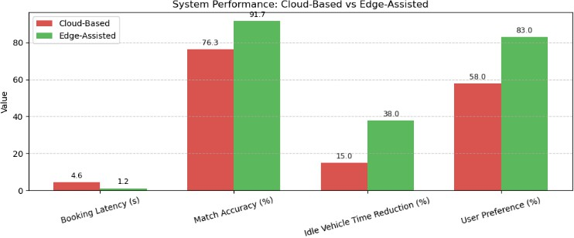

Fig. 2. System Performance Metrics
Figure 2. System Performance Metrics – Graphical representation of system performance showing improvements in latency, accuracy, and utilization achieved by the proposed edge-assisted architecture.
- Booking Latency
By employing localized edge processing, the system improved responsiveness and user experience by 74%, cutting

the booking time from 4.6 seconds (cloud-based) to 1.2 seconds.
- Match Accuracy
By using real-time traffic, driver ratings, and location data, the context-aware algorithm outperformed the cloud-based model (76.3%) with a match accuracy of 91.7%.
- Idle Vehicle Time
Effective edge-based vehicle allocation resulted in a 38% decrease in idle time, which improved utilization and reduced fuel consumption.
- Network Resilience
Offline caching and delayed synchronization ensure uninterrupted service, and the system maintained 86% accuracy in low-connectivity environments.
- Scalability
Unlike the cloud model, which displayed bottlenecks beyond 600 users, stress testing with up to 1000 concurrent users revealed stable latency because load was distributed across edge nodes.
- User Input
Of the 30 participants, 83% favored the edge system due to its speed, offline functionality, and transparency.

CONCLUSION
In order to overcome the inherent drawbacks of traditional cloud-centric models, this paper has proposed a novel edge- assisted, context-aware architecture for real-time goods transportation systems. The suggested framework strikes a balance between responsiveness and long-term optimization by allocating computational intelligence to regional edge nodes while preserving centralized supervision for analytics and historical modeling. Especially in underserved and low- connectivity areas, the combination of secure communication protocols, federated learning, and IoT-based sensing guarantees operational dependability, scalability, and inclusivity. The architecture is flexible enough to adjust to changing logistics needs because it facilitates offline resilience, effective resource allocation, and modular integration with external platforms. Additionally, the strategy is in line with the main Sustainable Development Goals (SDGs) and global sustainability objectives, such as Industry, Innovation, and Infrastructure (SDG 9), Reduced Inequalities (SDG 10), and Sustainable Cities and Communities (SDG 11). Future improvements like predictive AI, blockchain integration, and autonomous fleet compatibility will make the suggested system a sustainable, inclusive, and future-ready basis for next-generation smart logistics ecosystems.

FUTURE WORK
Transparency, adaptability, and large-scale operational efficiency will be the main goals of future developments for the suggested edge-assisted, context-aware transportation system. In order to improve trust and traceability throughout logistics operations, blockchain integration will be investigated to offer safe, impenetrable transaction management and identity verification. Predictive analytics powered by AI will be integrated to enable proactive demand forecasting, eco-routing, and preventive maintenance, allowing for foresighted decision-making during periods of high demand. To guarantee interoperability between passenger, mixed logistics, and goods services, multi-modal transport support will be developed. Furthermore, the system will be in line with international sustainability goals if green logistics techniques are incorporated, such as tracking carbon footprints and optimizing routing for lower emissions. Real- time ultra-low-latency decision-making will be supported by utilizing developments in 5G-enabled mobile edge computing, which will further lower inference latency. Vehicle allocation parameters will be dynamically adjusted by adaptive self-learning mechanisms in response to changing market trends, user behavior, and traffic conditions. In order to facilitate coordinated human-robotic logistics operations, the architecture will also be expanded to accommodate autonomous and semi-autonomous fleets with integrated V2X communication. In order to confirm scalability, resilience, and inclusivity under realistic operating conditions, extensive, real-world deployments will be carried out in a variety of geographic and socioeconomic contexts.

REFERENCES
- R. Dintén, S. García, and M. Zorrilla, “Fleet management systems in Logistics 4.0 era: A real-time distributed and scalable architectural proposal,” Procedia Computer Science, vol. 217, pp. 806–815, 2023.
- Kotsialos and P. Vassilakopoulou, “Fleet management enterprise systems and traffic control synergies: A literature review and research agenda,” Procedia Computer Science, vol. 219, pp. 529–536, 2023.
- Dui, S. Zhang, M. Liu, X. Dong, and G. Bai, “IoT-enabled real-time traffic monitoring and control management for intelligent transportation systems,” IEEE Internet of Things Journal, vol. 11, no. 9, pp. 15842–15854, 2024.
- Y. Yin, H. Wang, and X. Deng, “Real-time logistics transport emission monitoring: Integrating artificial intelligence and Internet of Things,” Transportation Research Part D: Transport and Environment, vol. 136, p. 104426, 2024.
- Elassy, M. Al-Hattab, M. Takruri, and S. Badawi, “Intelligent transportation systems for sustainable smart cities,” Transportation Engineering, vol. 16, p. 100252, 2024.
- A. Hazarika, N. Choudhury, M. M. Nasralla, S. B. A. Khattak, and I. U. Rehman, “Edge ML technique for smart traffic management in intelligent transportation systems,” IEEE Access, vol. 12, pp. 25443–25458, 2024.
- R. Zhang, J. Mao, H. Wang, B. Li, X. Cheng, and L. Yang, “A survey on federated learning in intelligent transportation systems,” IEEE Transactions on Intelligent Vehicles, 2024.
- X. Zhou, W. Liang, A. Kawai, K. Fueda, J. She, and K. I. K. Wang, “Adaptive segmentation enhanced asynchronous federated learning for sustainable intelligent transportation systems,” IEEE Transactions on Intelligent Transportation Systems, vol. 25, no. 7, pp. 6658–6666, 2024.
- Belkacem, “Integrating edge and cloud computing for efficient big data processing in IoT environments: Enhancing smart city applications with fog computing,” Studies in Knowledge Discovery, Intelligent Systems, and Distributed Analytics, vol. 14, no. 9, pp. 1–14, 2024.
- Afzal, Z. Ahmad, and A. Algarni, “A latency-aware and fault-tolerant framework for resource scheduling and data management in fog-enabled smart city transportation systems,” Computers, Materials & Continua, vol. 82, no. 1, 2025.
- A. Manchanda, P. P. Jayaraman, A. Banerjee, K. Fizza, and A. Zaslavsky, “Adaptive context monitoring framework for enhancing caching efficiency in context management platforms,” IEEE Access, 2024.
- Nagappan, K. G. Maheswari, and C. Siva, “Enhancing intelligent transport systems: A cutting-edge framework for context-aware service management with hybrid deep learning,” Simulation Modelling Practice and Theory, vol. 135, p. 102979, 2024.
- Fang, W. Zhou, and L. Xiong, “Multi-criteria decision making approach for supplier selection and order allocation in a digital supply chain resilience,” Annals of Operations Research, pp. 1–37, 2024.
- Z. Z. Li, J. Zhao, H. Cui, E. X. Zheng, X. Ma, D. Y. Liu, and M. H. Au, “Blockchain for smart logistics: Enhancing identity security, bidding transparency and goods tracking,” in Proc. 6th ACM Int. Symp. Blockchain and Secure Critical Infrastructure, Jul. 2024, pp. 1–9.
- A. P. Salave, “Cloud edge hybrid deep learning framework for real-time traffic management,” in ECCSUBMIT Conf., vol. 3, no. 2, pp. 28–39, Jun. 2025.
- Z. Maamar, A. Benna, S. Yangui, M. Pezongo, and E. Kajan, “On-demand bundling of cloud and edge services,” in Proc. Int. Conf. Web Information Systems Engineering, Singapore: Springer Nature Singapore, Nov. 2024, pp. 289–300.
- F. B. Shaikat, “Bridging the smart manufacturing divide: A low-code IIoT platform for rural and underserved US factories,” Authorea Preprints, 2025.
- S. Moazzeni and F. Sgarbossa, “Collaborative logistics and digital technologies in rural contexts: A systematic review and a decision aid model for logistics decision-makers,” 2025.
- S. Hudda and K. Haribabu, “A review on WSN-based resource-constrained smart IoT systems,” Discover Internet of Things, vol. 5, no. 1, p. 56, 2025.
- S. Kaleem, A. Sohail, M. Babar, A. Ahmad, and M. U. Tariq, “A hybrid model for energy-efficient green Internet of Things enabled intelligent transportation systems using federated learning,” Internet of Things, vol. 25, p. 101038, 2024.

